**­­­Republic of the Philippines**

**UNIVERSITY OF SOUTHEASTERN PHILIPPINES**

**COLLEGE OF INFORMATION AND COMPUTING**

Iñigo St., Obrero, Davao City, 8000



ORGANIZATION INFORMATION SYSTEM

Analysis, Design and Implementation

BSIT 2A

***Developers:***

*Aguilar, Aimee Grace D.*

*Antalan, Akela Paulene B.*

*Valenzona, Shekinah Jane E.*

JUNE 2020

**TABLE OF CONTENTS**

1. **EXECUTIVE SIMMARY ……………………………….... *page 3***
2. **REQUIREMENT SPECIFICATION ……………………….... *page 5*** 
   1. **Existing Information System ………………………… *page 5***
   2. **The Proposed System ………………………… *page 6***

**2.3 Scope ………………………………………… *page 7***

1. **CONCEPTUAL DATABASE DESIGN ………………… *page 8***

**3.1 Identified User Views ……………………………………… *page 8***

**3.2 Conceptual Data Model ……………………………………… *page 9***

1. **LOGICAL DATABASE DESIGN ………………………… *page 10***

**4.1 Logical Data Model …………………………………………. *page 10***

1. **PHYSICAL DATABASE DESIGN ………………… *page 12***
   1. **Physical Data Model ………………………………………… *page 12***
   2. **Final Data Dictionary ………………………………………… *page 13***
   3. **Final Normalized Table ……………………………………. *page 17***
   4. **Integrity Constraints ……………………………………….. *page 17***
   5. **Triggering Operations ……………………………………… *page 18***
   6. **Views ………………………………………………………… *page 19***
   7. **Stored Procedures and Functions …………………………. *page 20***
2. **CURRICULUM VITAE ……………………………….. *page 25***

# I. EXECUTIVE SUMMARY

This paper is worried about organizational information frameworks. Instances of such frameworks incorporate knowledge frameworks, correspondences frameworks, the management data frameworks, and regulatory control frameworks. Systems such as these are basic to an association's working; undoubtedly to its endurance.

Essential organizational capacities are empowered or improved by information systems. These systems offer help for business activities; for individual and cooperative choice creation; for advancement through new item and procedure improvement; for associations with clients, providers, and accomplices; for quest for upper hand; and, now and again, for the plan of action itself (e.g., Google). Information systems carry new alternatives to the manner in which organizations associate and contend, the manner in which associations are organized, and the manner in which work environments are structured. By and large, utilization of online data systems can essentially bring down the expenses of correspondence among labourers and firms and cost-adequately improve the coordination of flexibly chains or networks. This has driven numerous associations to focus on their centre capabilities and to redistribute different pieces of their worth chain to particular organizations. The ability to convey data effectively inside a firm has prompted the sending of compliment authoritative structures with less various levelled layers.

OIS is an automated collecting, storing, accessing, managing and monitoring of data on a single platform. The system was solely built to lessen the burden of data storing by business organizations and companies. The system has staff management, financial management, events management, monitoring management and reports.

The system has the features of adding, updating, deleting and viewing functions for each management. Where it can record the staffs, activities and basic cash flow that includes the income and expenses of the organization. Another feature of the system is the posting of all the accomplished activities within the system. Staffs can upload photos, accomplishment reports, attendance of events and other pertinent activities.

In a system association, long-term corporate partners supply goods and services through a central hub firm. Together, a system of generally little organizations can introduce the presence of a huge company. Without a doubt, at the centre of such an association might be simply a solitary business person upheld by just a couple of workers. Along these lines, arrange association shapes an adaptable environment of organizations, whose development and work is composed around online data systems.

In a bunch association, the chief work units are lasting and impermanent groups of people with reciprocal abilities. Colleagues, who are frequently generally scattered far and wide, are extraordinarily aided their work by the utilization of Web assets, corporate intranets, and cooperation frameworks. Worldwide virtual groups can work nonstop, moving information work electronically "to follow the sun." Data frameworks conveyed over portable stages have empowered representatives to work outside the corporate workplaces as well as for all intents and purposes anyplace. "Work is the thing you do, not the spot you go to" turned into the motto of the rising new working environment. Virtual work environments incorporate home workplaces, local work communities, clients' premises, and versatile workplaces of individuals, for example, protection agents. Representatives who work in virtual working environments outside their organization's premises are known as telecommuters.

# II. REQUIREMENTS SPECIFICATION

## 2.1 Existing Information Systems

HoneyBook is an all-in-one business management platform and company management system.

HoneyBook helps creative professionals in the events industry get organized, elevate their brand, and deliver the digital booking and payment experience their clients expect. The platform handles pesky, time-consuming processes and gets them booked and paid faster with beautiful digital proposals, e-signatures, and online payments & reminders. Knowing these businesses rely on their client-facing branding and reputation, HoneyBook solicits trust as early as it’s on boarding process.

Top features:

* Mobile app so you can manage your business on the go
* Proposals and invoices optimized to get you booked
* Contracts your clients can sign in seconds
* Easy and intuitive workflows
* Design forward client experience

The clients who gave HoneyBook a negative review grumbled that the product contains system bugs and that a few messages they send end up on their customer's garbage envelopes. Some referenced that it takes a few days for instalments from their customers to be kept on their financial balances. Others added that it needs to incorporate some extra data fields on its receipt.

Odoo is an all-in-one business management software that offers a range of business applications which forms a complete suite of enterprise management applications. It covers CRM, eCommerce, accounting, inventory, sales, and project management. Odoo apps are perfectly integrated with each other, allowing you to fully automate your business processes.

Top features:

* Unique framework with strong technical foundations
* Take a quick look at your business with dashboards
* Real-time communication makes way for better collaboration

An undeniable con is that Odoo requires a fairly intricate establishment and set-up process. This also implies the underlying expectation to learn and adapt will be very steep. In spite of the fact that the establishment procedure probably won't appear to be excessively significant when it's all said and done, it's as yet vital that you hit the nail on the head the first run through around. We frequently address organizations who have burnt through valuable time and assets because of a moderate and flawed establishment stage. Some problems are complicated pricing plans and lack of support.

## 2.2 The Proposed System

The Organization Information System is an electronic database of monetary and fundamental data sorted out and customized so that it produces normal reports on activities for the four office in an organization. It is typically likewise conceivable to acquire exceptional reports from the framework without any problem. The fundamental reason for the OIS is to give chiefs criticism about their own presentation; top administration can screen the organization in general. The system covers the storing of data like staff details, organization details, finances and reports.

The system objectives are: Build an automated collecting, storing, accessing, managing and monitoring of data, generate a single platform for all the transactions of a particular organization, improve the organizations transparency to its staffs, produce a friendly-user system that helps to improve the organizations storing of data.

The Organization information system contains data about an organization and its general condition. Three fundamental exercises—information, handling, and yield—produce the data associations need. Feedback is yield come back to suitable individuals or exercises in the association to assess and refine the information. Ecological entertainers, for example, clients, providers, contenders, investors, and administrative offices, interface with the organization and its information system. So as to appropriately make this relationship, a primary key must be chosen for each table. This key is a unique identifier for each record in the table. The system is used by the staff in the four departments and each staff is given only one entry to be submitted. The system is monitored by the admin.

## 2.3 Scope

The system covers the database of staff, finance, events, organization and reports. The system also display all the reports in the monitoring area.

Areas, departments, offices are covered and other boundaries of the system:

* Human Resource Department,
* Finance Department
* Administration and Management Department
* IT Department

Users of the system

* Admin (monitors all the reports)

The system covers of adding and editing staff information details, managing the reports, managing the financial status of the organization, managing the events and monitoring all the reports. It can also view the specific field you want to be viewed.

# III. CONCEPTUAL DATABASE DESIGN

## 3.1 Identified User Views

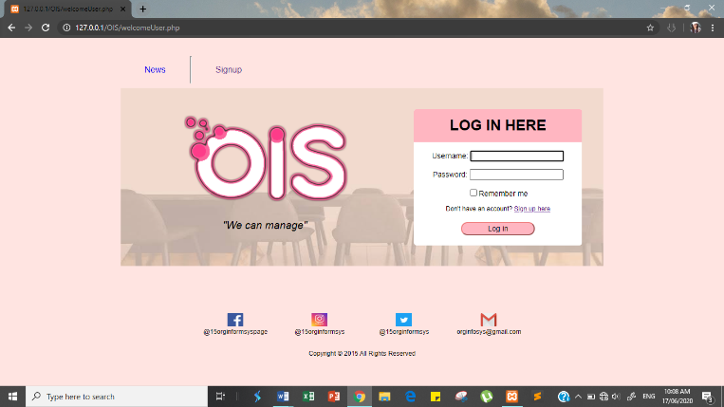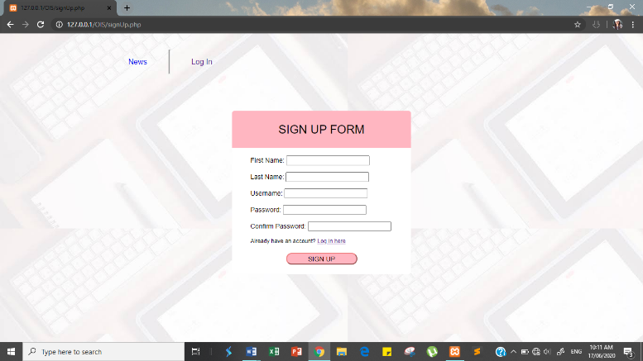 .

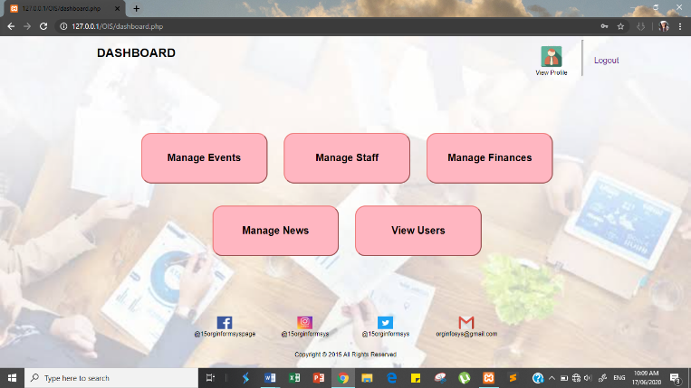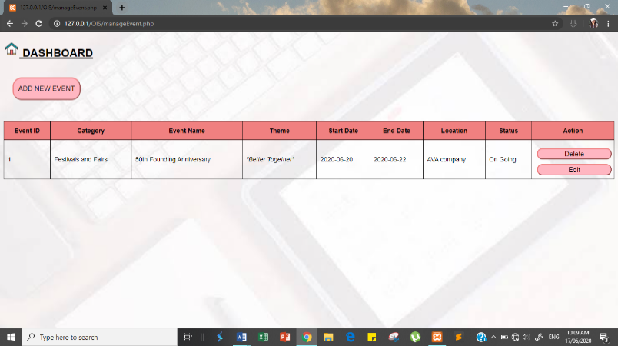

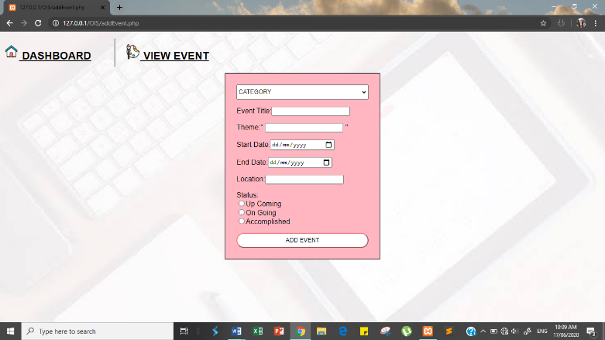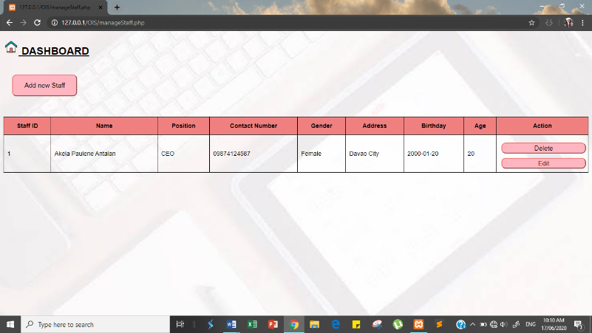

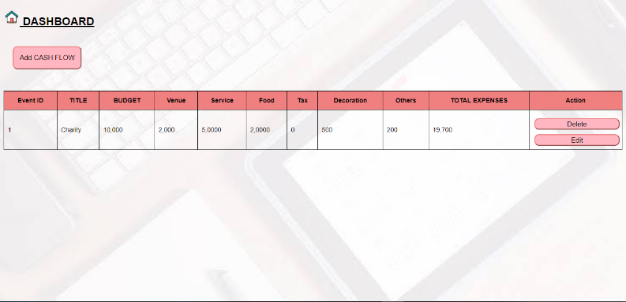

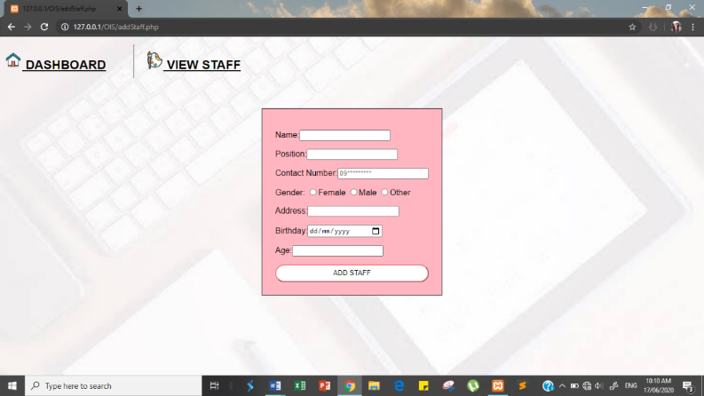

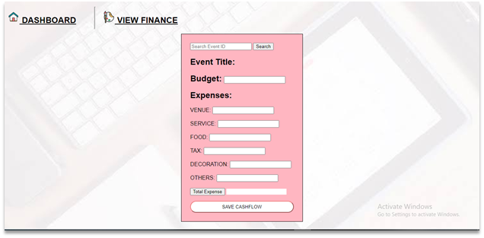

## 3.2 Conceptual Data Model

A conceptual data model is a model of the things in the business and the connections among them, as opposed to a model of the information about those things. So, in a conceptual data model, when you see an element type called vehicle, at that point you should consider bits of metal with motors, not records in databases. Thus, conceptual data model as a rule have scarcely any, characteristics. What might regularly be characteristics likely could be treated as substance types or relationship types in their own right, and where data is thought of, it is considered as an item in its own right, instead of as being essentially about something different. A conceptual data model may at present be adequately ascribed to be completely instantiable, however as a rule into some degree nonexclusive way.

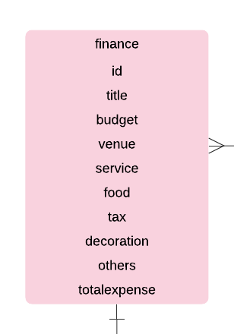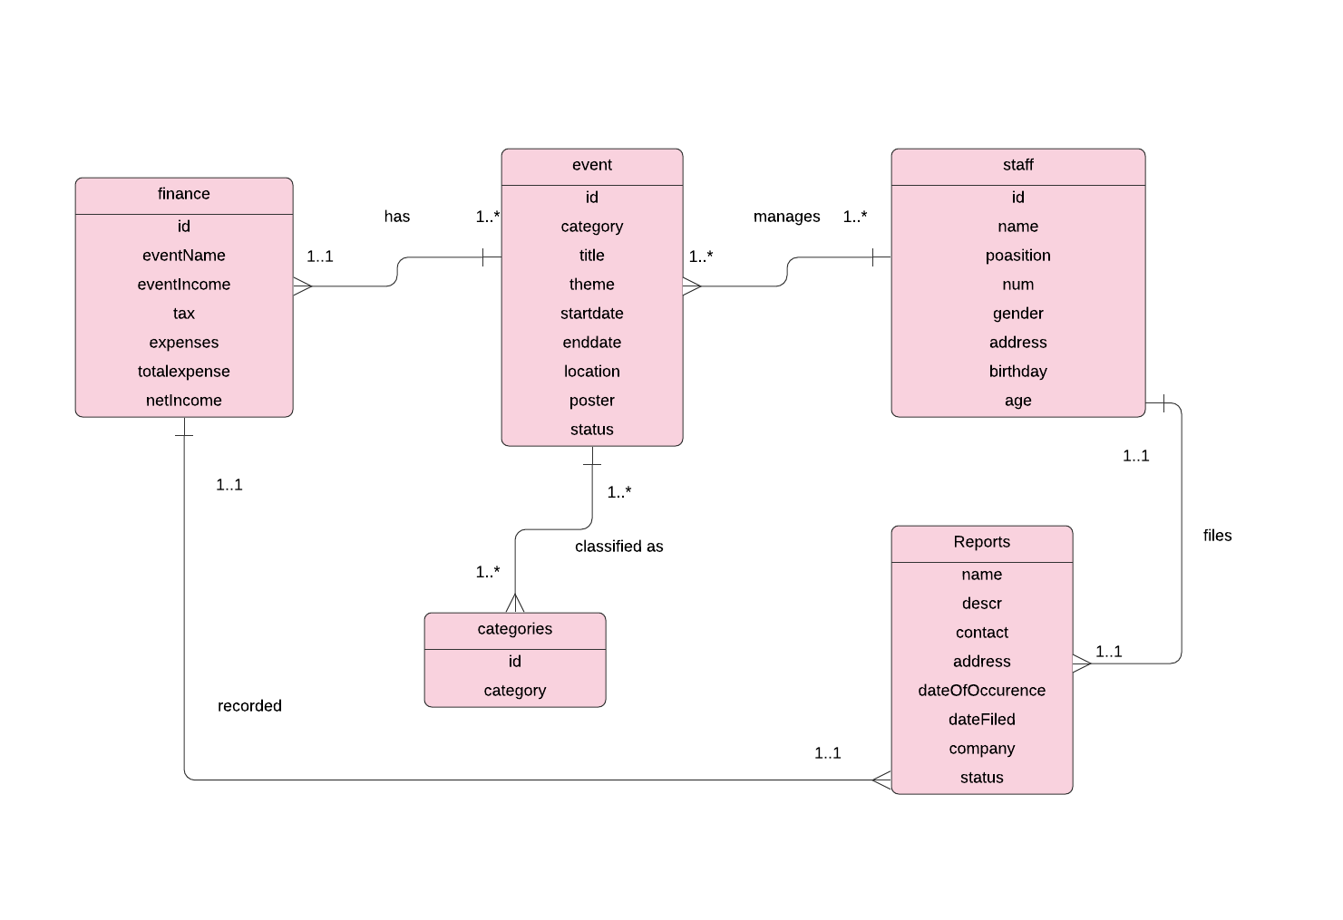

IV. **LOGICAL DATABASE DESIGN**

## 4.1 Logical Data Model

A logical data model depicts the information in however much detail as could be expected, regardless of how they will be physical executed in the database.

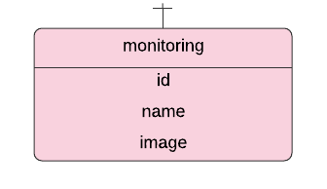 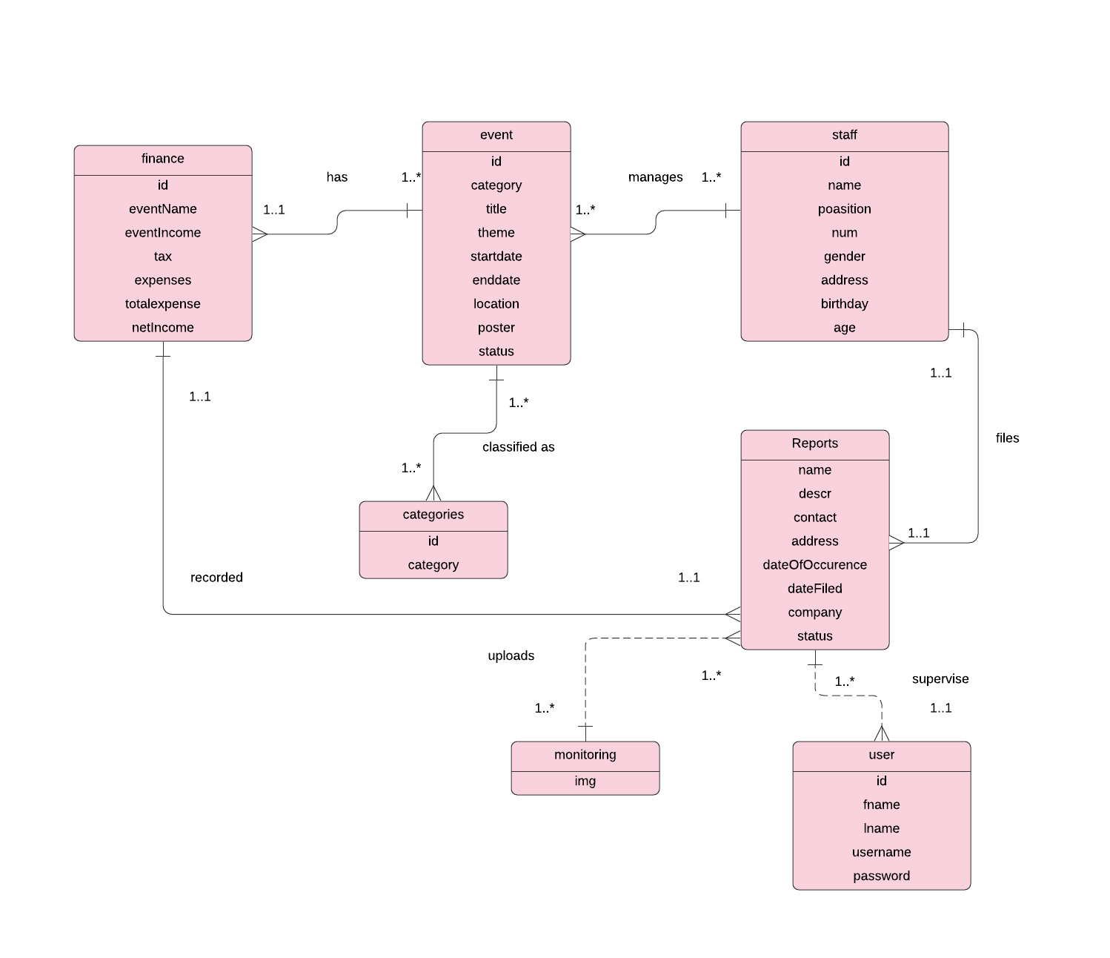

The changes in the data model is that the ‘user’ is added in the relationship of the Reports since the user is the one who is able to access the system and ‘monitoring’ since all data is display in the monitoring part and a photo is added when wanted to.

V. **PHYSICAL DATABASE DESIGN**

## 5.1 Physical Data Model

A physical data model characterizes the entirety of the intelligent database segments and administrations that are required to construct a database or can be the design of a current database.

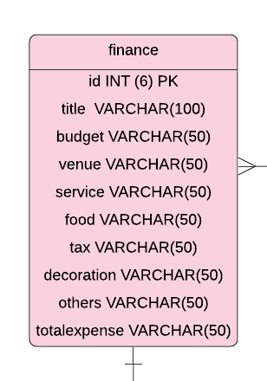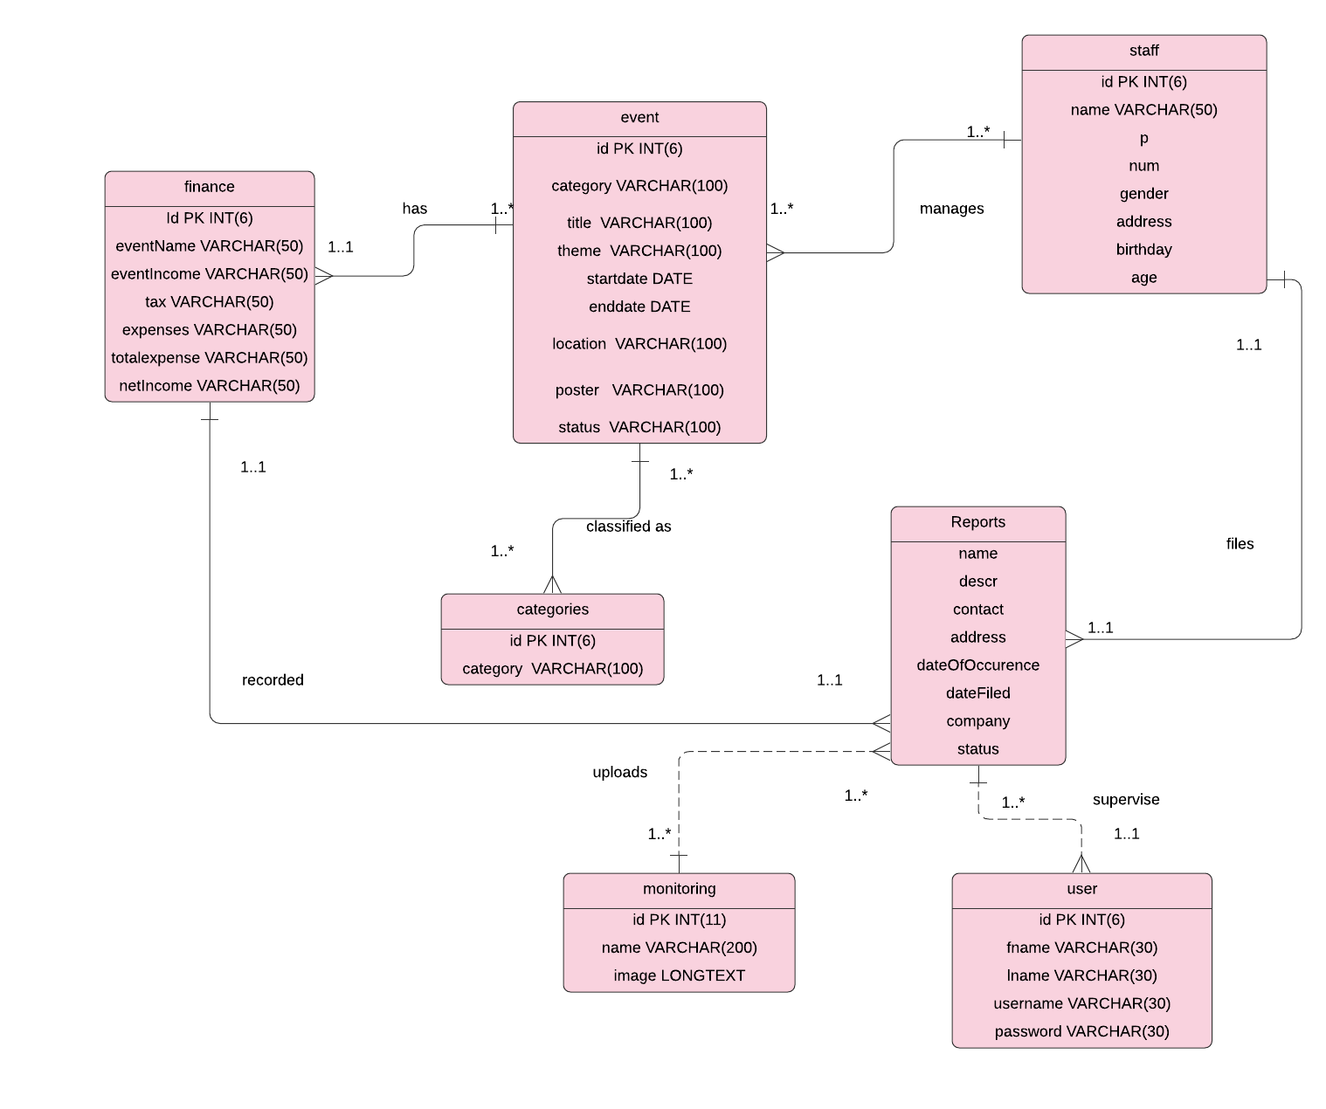

## 5.2 Final Data Dictionary

|  |  |  |  |  |  |  |  |  |
| --- | --- | --- | --- | --- | --- | --- | --- | --- |
| **Attributes** | **Description** | **Type** | **Size** | **Null** | **Unique** | **Part of PK** | **Foreign Key** | **FK Relation** |
| **Table Name: staff** | | | | | | | | |
| id | ID | Integer | 6 | No | Yes | Yes | No |  |
| name | Name | Variable Character | 50 | No | No | No | Yes | Reports |
| position | Position | Variable Character | 150 | No | No | No | No |  |
| num | Contact Number | Variable Character | 11 | No | No | No | No |  |
| gender | Gender of the staff | Variable Character | 10 | No | No | No | No |  |
| address | Address of the staff | Variable Character | 10 | No | No | No | No |  |
| birthday | Birthday of the staff | Date |  | No | No | No | No |  |
| age | Age of the staff | Integer |  | No | No | No | No |  |
| **Table Name: user** | | | | | | | | |
| id | Id | Integer | 6 | No | Yes | Yes | No |  |
| fname | Firstname | Variable Character | 30 | No | No | No | No |  |
| lname | Lastname | Variable Character | 30 | No | No | No | No |  |
| username | Username | Variable Character | 30 | No | No | No | No |  |
| password | Password | Variable Character | 30 | No | No | No | No |  |
| **Table Name: Reports** | | | | | | | | |
| name | Name of the Staff | Variable Character | 50 | No | Yes | Yes | Yes | staff |
| descr | Description of the report | Variable Character | 255 | No | No | No | No |  |
| contact | Contact Number of the staff | Integer | 11 | No | No | No | No |  |
| address | Address | Variable Character | 50 | No | No | No | No |  |
| dateOfOccurence | Date of Occurrence | Date |  | No | No | No | No |  |
| dateFiled | Date Filed | Date |  | No | No | No | No |  |
| company | Company Name | Variable Character | 50 | No | No | No | No |  |
| status | Status of the report | Variable Character | 50 | No | No | No | No |  |
| **Table Name: finance** | | | | | | | | |
| id | Id | Integer | 6 | No | Yes | Yes | No |  |
| title | Title of the event | Variable Character | 100 | No | No | No | No |  |
| budget | Budget of the event | Variable Character | 50 | No | No | No | No |  |
| venue | Venue of the event | Variable Character | 50 | No | No | No | No |  |
| service | Service offered | Variable Character | 50 | No | No | No | No |  |
| food | Food | Variable Character | 50 | No | No | No | No |  |
| tax | Tax | Variable Character | 50 | No | No | No | No |  |
| decoration | Decoration | Variable Character | 50 | No | No | No | No |  |
| others | Others | Variable Character | 50 | No | No | No | No |  |
| totalexpense | Total Expenses | Variable Character | 50 | No | No | No | No |  |
| **Table Name: event** | | | | | | | | |
| id | Id | Integer | 6 | No | Yes | Yes | No |  |
| category | Category of the event | Variable Character | 100 | No | No | No | No |  |
| Title | Title of the event | Variable Character | 100 | No | No | No | No |  |
| theme | Theme of the event | Variable Character | 100 | No | No | No | No |  |
| startdate | Start date | Date |  | No | No | No | No |  |
| enddate | End date | Date |  | No | No | No | No |  |
| location | Location | Variable Character | 1000 | No | No | No | No |  |
| poster | Poster of the event | Variable Character | 100 | No | No | No | No |  |
| status | Status of the event | Variable Character | 50 | No | No | No | No |  |
| **Table Name: categories** | | | | | | | | |
| id | Id | Integer | 6 | No | Yes | Yes | No |  |
| category | Category of the event | Variable Character | 100 | No | No | No | No |  |
| **Table Name: monitoring** | | | | | | | | |
| id | Id | Integer | 11 | No | Yes | Yes | No |  |
| name | Name | Variable Character | 200 | No | No | No | No |  |
| image | Image | Longtext |  | No | No | No | No |  |

## 5.3 Final Normalized Tables

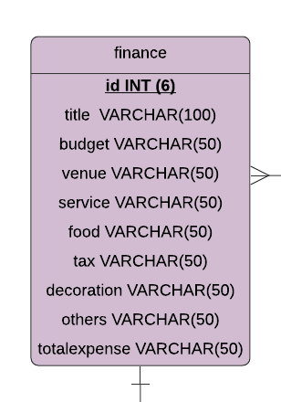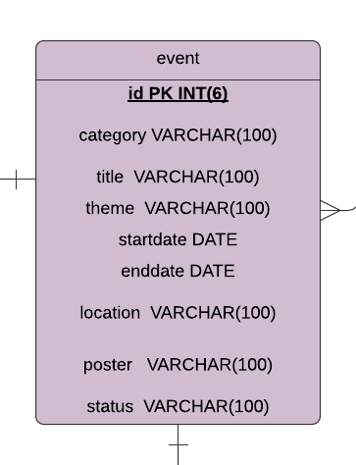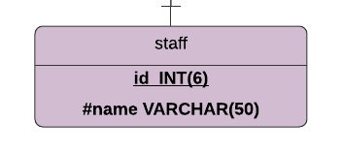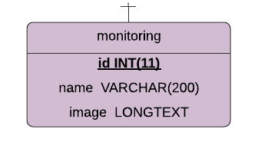 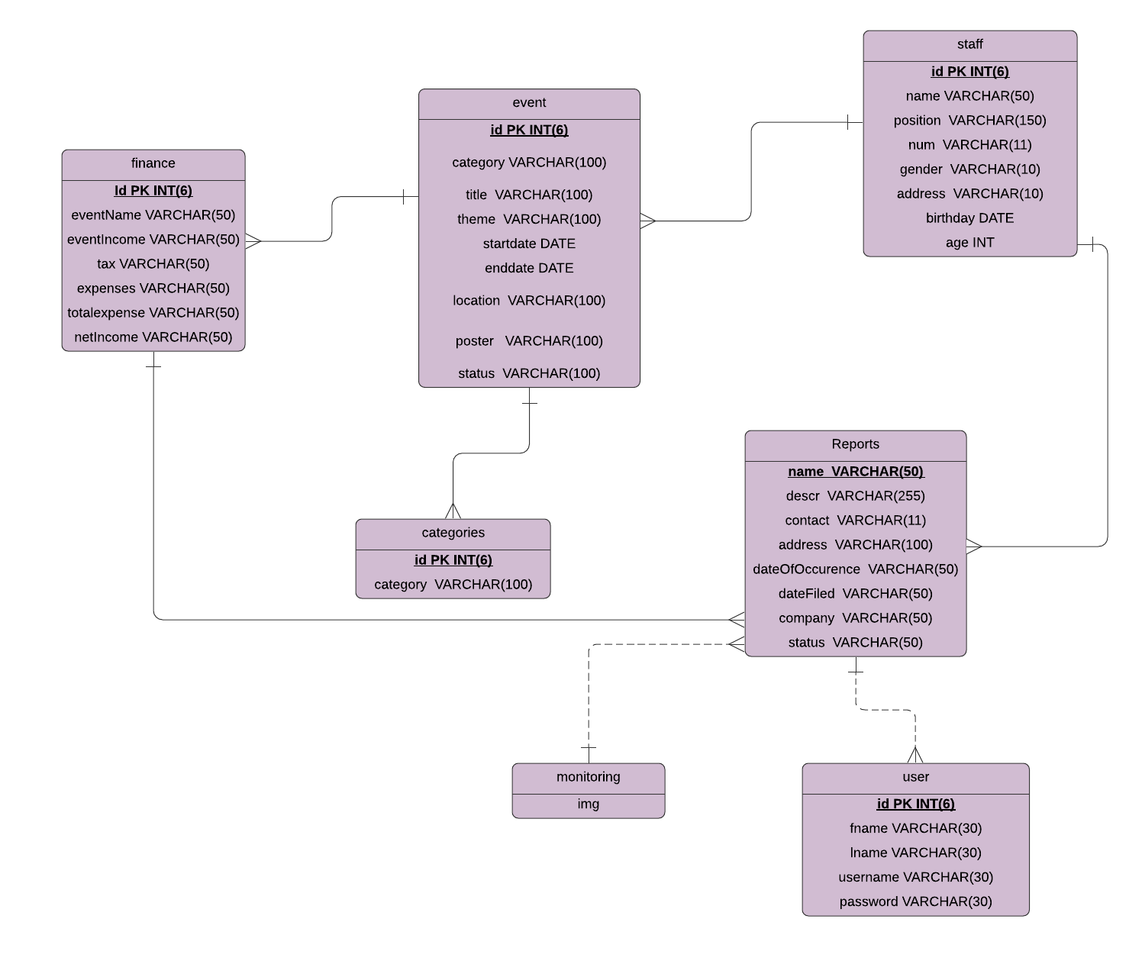

## 5.4 Integrity Constraints

|  |
| --- |
| * **FINANCES & EVENT**   + **Every FINANCES must have a corresponding EVENT record to it.**   + **Once a FINANCE record is being deleted/updated, EVENT record will not be deleted/updated.** |
| * **REPORTS & EVENT/FINANCE**   + **For every EVENT OR FINANCE, there should be one entry of NEWS.**   + **Once a NEWS record id being added/uploaded (image), the record will be stored on the database only.** |

## 5.5 Triggering Operations

|  |  |
| --- | --- |
| User Rule | Staff must not be existing |
| Event | Insert |
| Entity Name | staff |
| Condition | DELIMITER //  CREATE TRIGGER before_staff_update  BEFORE UPDATE ON staff  FOR EACH ROW  BEGIN  INSERT INTO reports_staff  SET action = ‘update’,  name = OLD.name,  position = NEW.position;  END; //  DELIMITER; |
| Action | After insert action |

## 5.6 Views

|  |
| --- |
| Description:  Two columns are combined, reports and the staff’s name and position. |
| Code:  CREATE VIEW reports_staff AS SELECT name,position FROM staff WHERE 1 |
| Screenshot: |

|  |
| --- |
| Description:  Two co;umns are combined to create view of finance title and event’s category. |
| Code:  CREATE VIEW finance_v_event AS SELECT title,category FROM event WHERE 1 |
| Screenshot: |

## 5.7 Stored Procedures and Functions

Function is a database object in SQL Server. Fundamentally, it is a lot of SQL proclamations that acknowledge just information boundaries, perform activities and return the outcome. Capacity can restore a lone single worth or a table. A stored procedure is a precompiled set of at least one SQL proclamations that are put away on SQL Server.

|  |
| --- |
| Description:  A SQL inquiry utilizing the CREATE DATABASE statement, after that we will execute this SQL query through passing it to the PHP query($sql) capacity to at last make our database. The accompanying model makes a database named OISDb. |
| Code:  session_start();  $servername = "localhost"; $username = "root"; $password = "";  //create connection  $conn = new mysqli($servername, $username, $password);  //check connection  if($conn->connect_error){      die("Connection failed: ".$conn->connect_error);  }  //create database  $sql = "CREATE DATABASE OISDb";  if($conn->query($sql) === TRUE)      echo "Database created successfully";  else      echo "Error creating database: ".$conn->error;  //close the database connection  $conn->close();  ?> |

|  |
| --- |
| Description:  We utilize the SQL command 'CREATE TABLE' to make a table. The table name are user, staff, categories, event, Reports, finance and monitoring.   * Field Property NOT NULL is being utilized on the grounds that we don't need this field to be NULL. Along these lines, if a client will attempt to make a record with an NULL worth, at that point MySQL will raise a mistake. * Catchphrase PRIMARY KEY is utilized to characterize a segment as an essential key. You can utilize multiple columns isolated by a comma to characterize a primary key. * VARCHAR: Holds a variable length string that can contain letters, numbers, and exceptional characters. The most extreme size is indicated in enclosure. * INT: Number information type acknowledges numeric qualities with a suggested size of zero. It stores any whole number an incentive between - 2147483648 to 2147483647. |
| $usql = "CREATE TABLE IF NOT EXISTS user(      id INT(6) UNSIGNED AUTO_INCREMENT PRIMARY KEY,      fname VARCHAR(30) NOT NULL,      lname VARCHAR(30) NOT NULL,      username VARCHAR(30) NOT NULL,      password VARCHAR(30) NOT NULL  )";  $ssql = "CREATE TABLE IF NOT EXISTS staff(      id INT(6) UNSIGNED AUTO_INCREMENT PRIMARY KEY,      name VARCHAR(50) NOT NULL,      position VARCHAR(150) NOT NULL,      num VARCHAR(11) NOT NULL,      gender VARCHAR(10) NOT NULL,      address VARCHAR(100) NOT NULL,      birthday date NOT NULL,      age INT NOT NULL  )";  $csql = "CREATE TABLE IF NOT EXISTS categories(      id INT(6) UNSIGNED AUTO_INCREMENT PRIMARY KEY,      category VARCHAR(100) NOT NULL  )";  $esql = "CREATE TABLE IF NOT EXISTS event(      id INT(6) UNSIGNED AUTO_INCREMENT PRIMARY KEY,      category VARCHAR(100) NOT NULL,      title VARCHAR(100) NOT NULL,      theme VARCHAR(100) NOT NULL,      startdate date NOT NULL,      enddate date NOT NULL,      location VARCHAR(100) NOT NULL,      poster VARCHAR(100) NOT NULL,      status VARCHAR(50) NOT NULL  )";  $asql = "CREATE TABLE IF NOT EXISTS Reports(      name VARCHAR(50) UNSIGNED AUTO_INCREMENT PRIMARY KEY,      decr VARCHAR(255) NOT NULL,      contact VARCHAR(11) NOT NULL,      address VARCHAR(100) NOT NULL,      dateOfOccurence date NOT NULL,      dateFiled date NOT NULL,      company VARCHAR(50) NOT NULL,      status VARCHAR(50) NOT NULL  )";  $bsql = "CREATE TABLE IF NOT EXISTS finance(      title VARCHAR(100) UNSIGNED AUTO_INCREMENT PRIMARY KEY,      budget VARCHAR(50) NOT NULL,      venue VARCHAR(50) NOT NULL,      service VARCHAR(50) NOT NULL,      food VARCHAR(50) NOT NULL,      tax VARCHAR(50) NOT NULL,      decoration VARCHAR(50) NOT NULL,      others VARCHAR(50) NOT NULL,      totalexpense VARCHAR(50) NOT NULL  )";  $dsql= "CREATE TABLE IF NOT EXISTS monitoring (      id int(11) NOT NULL PRIMARY KEY AUTO_INCREMENT,      name varchar(200) NOT NULL,      image longtext NOT NULL  ) "; |

|  |
| --- |
| Description:  Information is entered into MySQL tables by executing SQL INSERT statement through PHP work mysql_query. Beneath a basic guide to embed a record into user table, categories table, staff table and Reports table.  VALUES statement. Here we indicate our qualities to embed into the recently determined segments. That way, every section speaks to a particular worth.  INSERT INTO is an explanation which includes information into the predefined database table. In this model, we are adding information to the table. |
| Code:  $adminsql = "INSERT INTO user (fname, lname, username, password) VALUES ('firstname', 'lastname', admin1', 'admin1')";      $firsql = "INSERT INTO categories (id, category) VALUES ('1', 'Festivals and Fairs')";      $secsql = "INSERT INTO categories (id, category) VALUES ('2', 'Seminars and Lectures')";      $thisql = "INSERT INTO categories (id, category) VALUES ('3', 'Charities')";      $fousql = "INSERT INTO categories (id, category) VALUES ('4', 'Fashion')";      $fifsql = "INSERT INTO categories (id, category) VALUES ('5', 'Sports and Active life')";      $sixsql = "INSERT INTO categories (id, category) VALUES ('6', 'Night Life')";  $sql = "INSERT INTO staff (id,name,position,num,gender,address,birthday,age) VALUES (1,'Akela','CEO','099999999999','Female','Samal City','01-20-2000',20),              (2,'Aimee','C0O','09888888888','Female','Pantukan','06-09-2000',20),(3,'Shekinah','CCO','09777777777','Female','Panabo City','09-28-2000',20)";          if(mysqli_query($conn, $sql)){  echo "Records inserted successfully.";      } else{      echo "ERROR: Could not able to execute $sql. " . mysqli_error($conn);      }      $sql = "INSERT INTO Reports (name,descr,contact,address,dateOfOccurence,dateFiled,company,status) VALUES ('Akela','The event needs a meeting soon.','09475687193','Samal City','06-18-2020','06-23-2020','Bighit','Pending'),              ('Aimee','Will attend the meeting.','09475687193','Pantukan','06-18-2020','06-23-2020','Bighit','Pending')  ";          if(mysqli_query($conn, $sql)){  echo "Records inserted successfully.";      } else{      echo "ERROR: Could not able to execute $sql. " . mysqli_error($conn);      } |

1. **CURRICULUM VITAE**



**AIMEE GRACE DAJAS AGUILAR**

Purok 2, Bongbong, Pantukan, Davao de Oro 8809

agdaguilar@usep.edu.ph

+63906

­­­­­­­­

|  |  |  |
| --- | --- | --- |
|  | Name of School | Year Graduated |
| College: | UNIVERSITY OF SOUTHEASTERN PHILIPPINES  Iñigo St., Obrero, Davao City 8000  Information Technology | 2018 – Present |
| Senior High School: | UNIVERSITY OF MINDANAO  Bolton St., Davao City 8000  Accountancy Business Management | 2016 – 2018 |
| ­­Junior High School: | PANTUKAN NATIONAL HIGH SCHOOL  Bonifacio St., Kingking, Pantukan,  Davao de Oro 8809 | 2012 – 2016 |
| Elementary School: | BONGBONG ELEMENTARY SCHOOL  Bongbong, Pantukan, Davao de Oro 8809 | 2006 – 2012 |

**PERSONAL INFORMATION**

Birthday: June 9, 2000

Father: Alexander V. Aguilar

Mother: Imelda D. Aguilar



**AKELA PAULENE B. ANTALAN**

Purok 1 Mambago-A, Island Garden City of Samal

apbantalan@usep.edu.ph

+639475687193

­­­­­­­­

|  |  |  |
| --- | --- | --- |
|  | Name of School | Year Graduated |
| College: | UNIVERSITY OF SOUTHEASTERN PHILIPPINES  Iñigo St., Obrero, Davao City 8000  Information Technology | 2018 – Present |
| Senior High School: | UNIVERSITY OF MINDANAO  Peñaplata, Island Garden City of Samal  General Academic Strand | 2016 – 2018 |
| ­­Junior High School: | ASSUMPTION ACADEMY OF  PEÑAPLATA INC.  Peñaplata, Island Garden City of Samal | 2012 – 2016 |
| Elementary School: | S.I.R. Elementary School  S.I.R. Matina, Davao City | 2006 – 2012 |

**PERSONAL INFORMATION**

Birthday: January 20, 2000

Mother: Marissa B. Antalan

Father: Clovis Anthony L. Antalan



**SHEKINAH JANE EBARLE VALENZONA**

Purok 3, Tagpore, Panabo City

sjevalenzona@usep.edu.ph­

+639564134455 / +639774232417

­­­­­­­­

|  |  |  |
| --- | --- | --- |
|  | Name of School | Year Graduated |
| College: | UNIVERSITY OF SOUTHEASTERN PHILIPPINES  Iñigo St., Obrero, Davao City 8000  Information Technology | 2018 – Present |
| Senior High School: | JOSE MARIA COLLEGE  Philippine-Japan Friendship High way, Catitipan, Davao City 8000  Accountancy Business Management | 2016 – 2018 |
| ­­Junior High School: | A.L. Navarro National High School  Lasang, Davao City 8000 | 2012 – 2016 |
| Elementary School: | TAGPORE ELEMENETARY SCHOOL  Purok 3, Tagpore, Panabo City | 2006 – 2012 |

**PERSONAL INFORMATION**

Birthday: October 28, 1999

Father: Earle Jone C. Valenzona

Mother: Mary Jane E. Valenzona